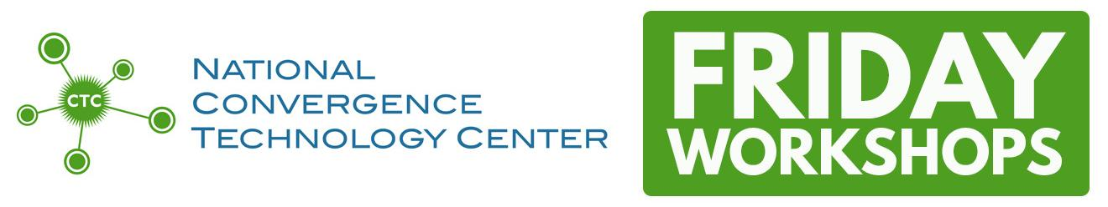

**Scripting for Networking Professionals**

**Fridays - February 3, 10, 17, 24; March 3  
9:00am-12noon and 1:00pm-5:30pm Central  
Registration has CLOSED**

Last day to register: Monday, January 30  
Last day to cancel without penalty: Monday, January 30

* Because of limited space and budget, we only allow TWO faculty members per school to attend each workshop. Additional interested faculty beyond the first two will be added to a wait list. If space permits, “wait listers” will be registered two weeks prior to the event.
* All attendees are required to complete a survey before they sign off from the program on the last Friday.
* Only those who attend every Friday session are eligible to receive a Certificate of Completion.

**Description**

The “Scripting for Network Professionals” course uses hands-on labs to demonstrate Python scripts used to manage, manipulate/configure, and monitor network devices. Students also use common industry tools in addition to the scripting language for a practical application of these skills.

**Textbook Recommendations** - not required  
  
Python Crash Course by Eric Matthes, 2nd Edition, 2019 No Starch Press, ISBN 9781593279288

Mastering Python Networking by Eric Chou, 3rd Edition, 2020 Packt Publishing Ltd., ISBN 9781839214677

**Pre-requisites**

* Cisco 1 is beneficial and strongly encouraged; Cisco 2 suggested but not required
* Knowledge of networking (IP Addresses, routers, switches) is essential.
* Python knowledge/experience is helpful, but not required; other programming languages will be sufficient.
* Git/GitHub will be used to deliver content and example code but we will cover that during the first class.

**At-home computer requirements**

* PC or Mac with a recent version of Python installed (3.1x). We use IDLE which comes with Python. Students can use any IDE, we just don’t provide support.
* Students will also want to have VMware Workstation Player or Workstation Pro.
* Using a workstation with two monitors may prove helpful as well.

**Instructors**

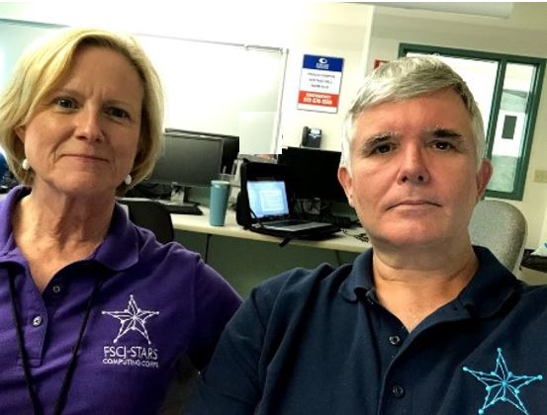

**Pamela Brauda** is a faculty member in the School of Technology at Florida State College at Jacksonville, where she teaches courses in programming, networking, database, and data science. Pamela is a co-designer of the new A.S. in Data Science Technology program at FSCJ, co-principal investigator for NSF Grant #1902524 “Meeting Industry Needs through a Two-Year Data Science Technician Education Program”, and faculty co-advisor for the FSCJ STARS Computing Corps. Before teaching at FSCJ, Pamela worked as a Metadata Analyst with the Florida Department of Law Enforcement, taught programming and software development at the University of North Florida, created and operated several small businesses, and taught high school mathematics. She graduated from the University of Georgia with a B.S. and from the University of North Florida with an M.S. in Computer Science.

**David Singletary** is a faculty member at Florida State College at Jacksonville (FSCJ), where he teaches courses in networking, software development, and data science. David is a co-designer of the new A.S. in Data Science Technology program at FSCJ, principal investigator for NSF Grant #1902524 “Meeting Industry Needs through a Two-Year Data Science Technician Education Program”, and faculty advisor for the FSCJ STARS Computing Corps. Previously, David worked as a software engineer for Cisco Systems and various Silicon Valley startup companies after serving in the U.S. Air Force. He graduated from the University of Central Florida with a B.S. in Computer Science and an M.S. in Computer Science from the University of Colorado.

**Objectives**

At the completion of this track, the participants will be able to…

* Write interactive, modular Python applications
  + using selection statements and loops
  + utilizing functions, both built-in and user-defined
  + using file input and output, and
  + using data structures such as lists, tuples, and dictionaries
* Create class definitions for objects and utilize Python object-oriented programming features, including encapsulation, name mangling, inheritance, polymorphism, and introspection.
* Construct and apply a script that
  + gathers information from network devices
  + creates a configuration change to multiple network devices to implement basic programming constructs

**Daily Agenda**

9:00am – 10:00am Review/Lesson  
10:00am – 10:30am Hands-on Lab  
10:30am – 10:45am Break  
10:45am – 11:30am Lesson  
11:30am – 12:00pm Hands-on Lab  
12:00pm – 1:00pm Lunch  
1:00pm – 1:30pm Hands-on Lab, continued  
1:30pm – 2:15pm Lesson  
2:15pm – 3:30pm Hands-on Lab  
3:30pm – 3:45pm Break  
3:45pm – 4:15pm Lesson  
4:15pm – 5:15pm Hands-on Lab  
5:15pm – 5:30pm Summary/Review/Assignments  
  
**Topics**

First three days are a sprint through topics that are on the PCEP and PCAP exams (from the NetAcad Python Essentials Course):

* February 3 - Data Types, Variables, Input-Output, Conditional Expressions, Repetition Structures, Git and GitHub

* February 10 - Lists, Tuples, Dictionaries, Functions

* February 17 - Modules & Packages, Strings, Exceptions

* February 24 - OOP, Classes, Working with Files, VMware and FishNet server setup

* March 3 - Application Programming Interfaces, Automation with Ansible

*Please note that content is subject to change or modification based on the unique needs of the track participants in attendance.*